310-Permit Project Completion Form

(Return Upon Completion of Project)

310-Permit Information
MONTANA 310 PERMIT #LC-_________________________________________________________
Landowner: _________________________________________________________________________
Applicant: ___________________________________________________________________________
Contractor (if applicable) ______________________________________________________________
Stream: ______________________________________________________________________________
Project Description: ___________________________________________________________________
Permit Expiration Date: ________________________________________________________________

Requirements
- The Applicant/Landowner is required to return this form to the Lewis and Clark Conservation District when work is completed or the permit expires.
- Please include Comparable pre-and-post photos of the project.

Date work completed ___________________________
Note: If work not completed, provide explanation below.

Explanation __________________________________________________________________________________________________________________________________________________________________________________________________________________________________________

Contact Information (Required for Follow-Up Inspection)
Name_______________________________________________________________________________

Address_____________________________________________________________________________
Phone/Cell #_________________________________________________________________________

Email_______________________________________________________________________________

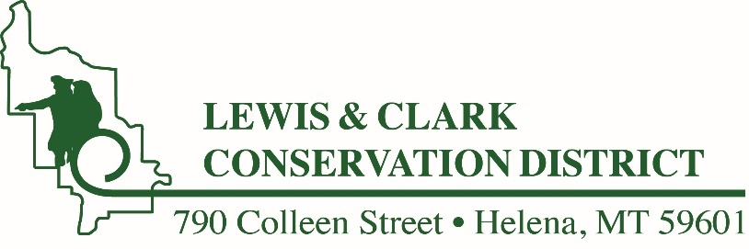
Mail to:
Lewis and Clark Conservation District
790 Colleen Street
Helena MT 59601

Or email to lccd@mt.net

