Website Information

Home Page
Site Name: Resource Conservation
Cascade Conservation District
The wise use of the earth and its resources for the lasting good of men.
Gifford Pinchot
Education/Resources
This conservation website provides a wealth of information on the following topics:
• 310 Permitting
• Education for youth and adult
• Living on the Land workshops
Grants
The Cascade Conservation District has resources that may help find financial support for landowners, teachers, and students.
Explore the options.
Water Resources
Is your home well impaired by iron bacteria?
You had your water tested – what do all these numbers mean?
Find the answers here!
About Us
Montana’s Conservation Districts provide local citizens with an opportunity to shape resource planning in their areas.
Get in Touch
- info@cascadecd.com
- (406) 770-4332
Drop By
12 Third St NW, Ste 300
Great Falls, MT 49404
USA
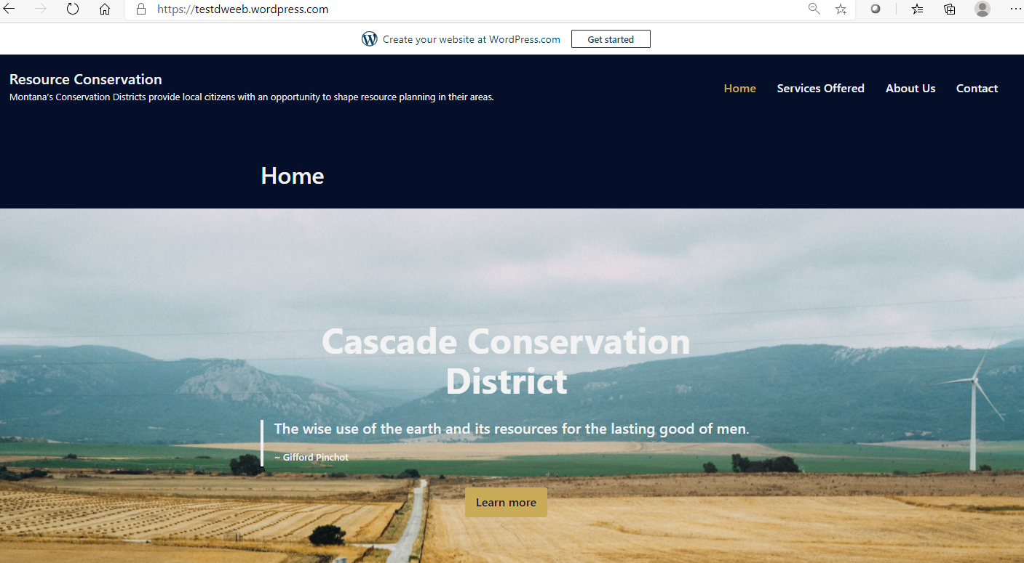
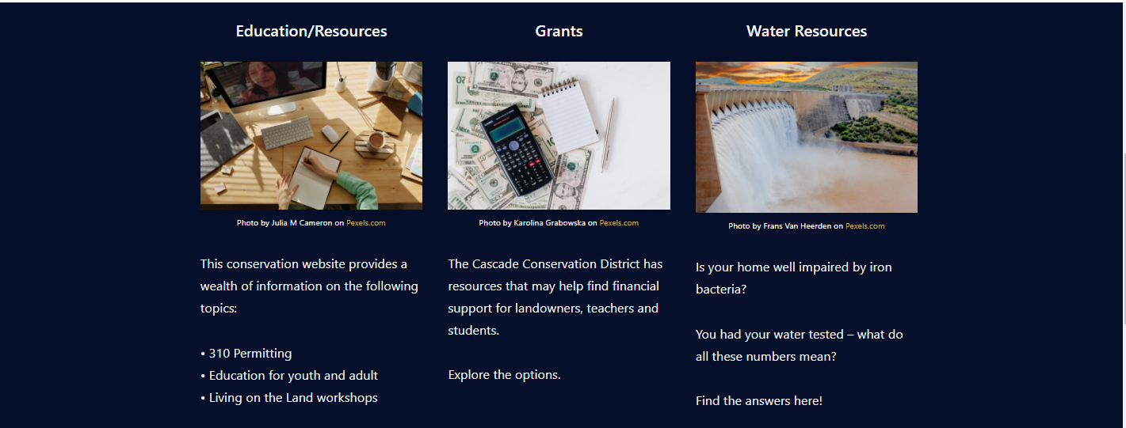
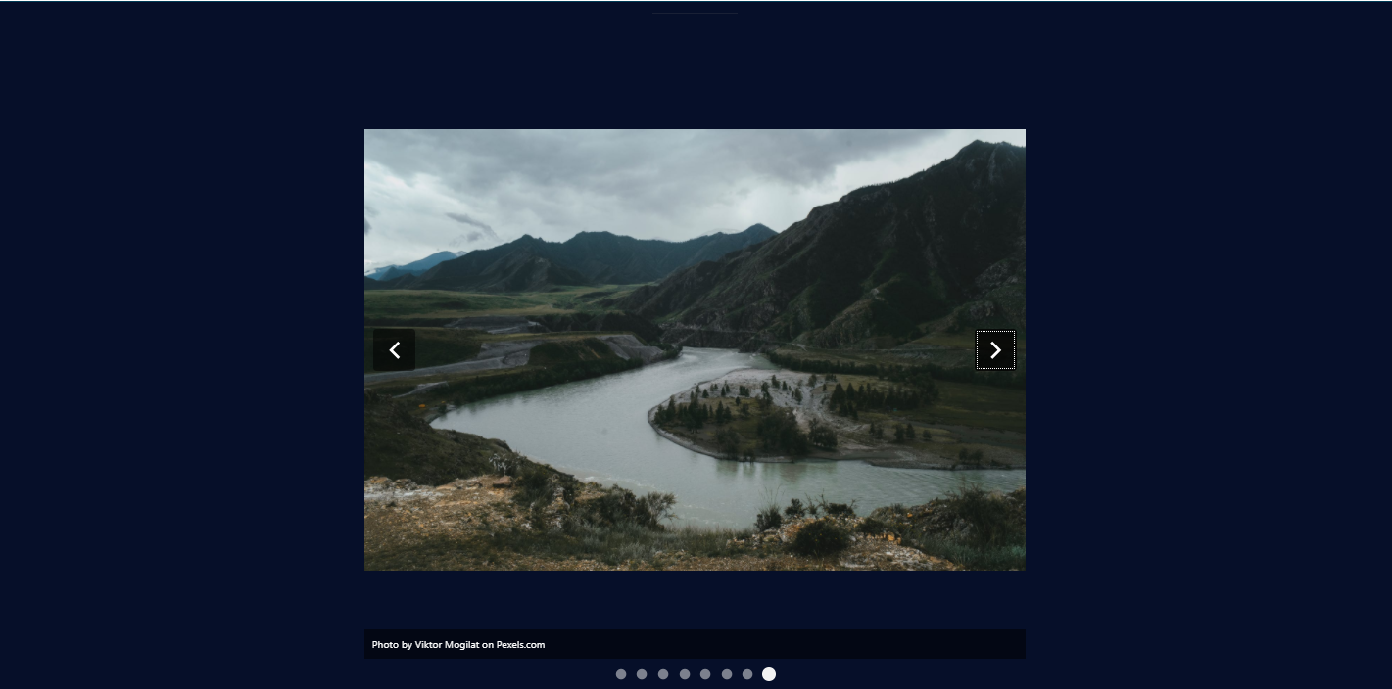
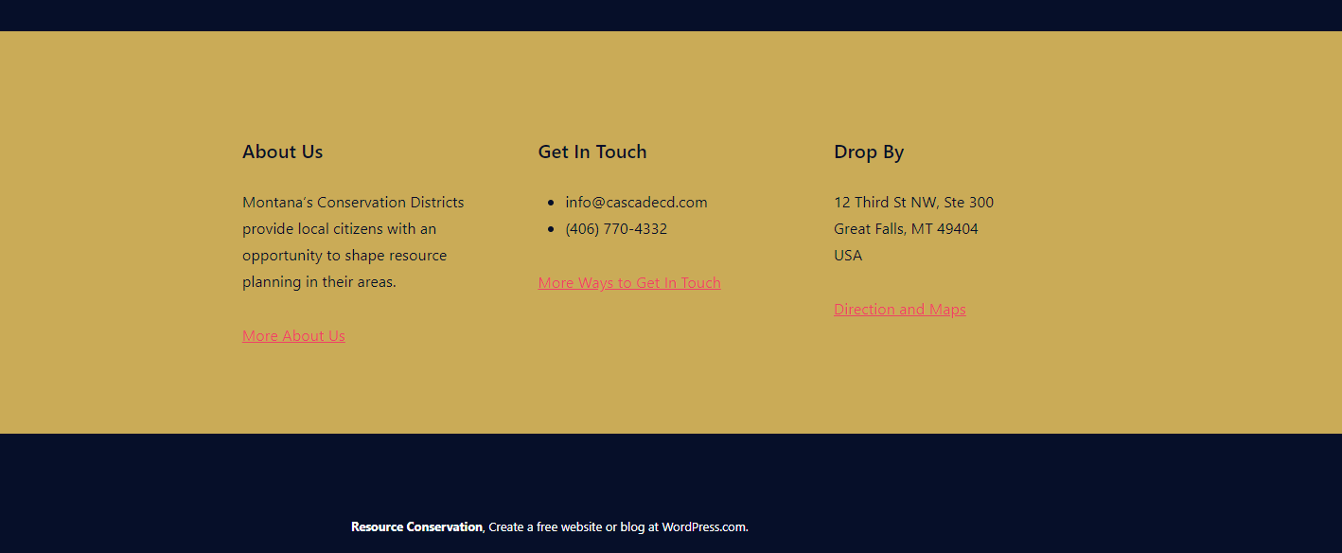
Tag Line: Conservation Districts provide citizens an opportunity to shape resource planning.

Services Offered Page
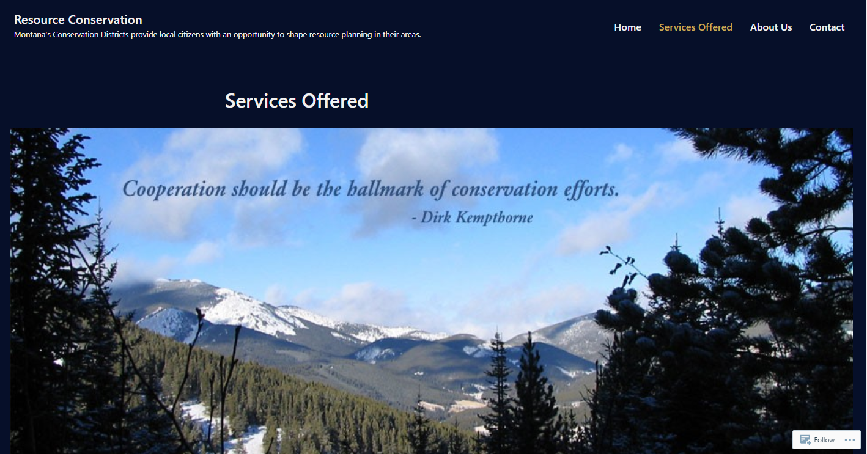
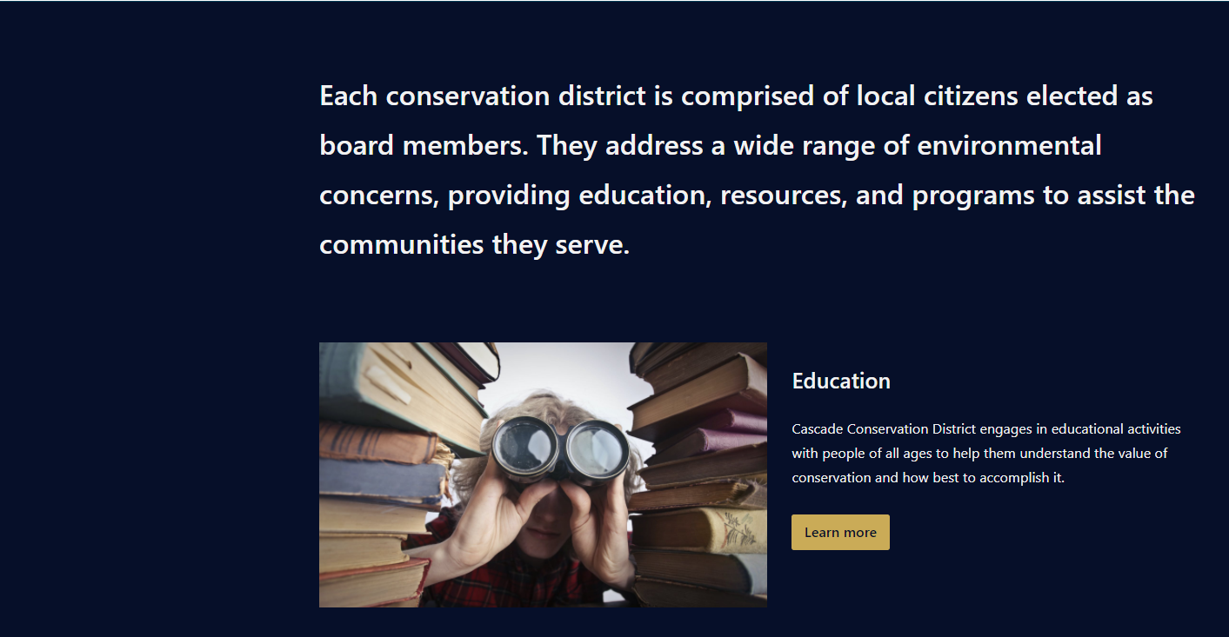

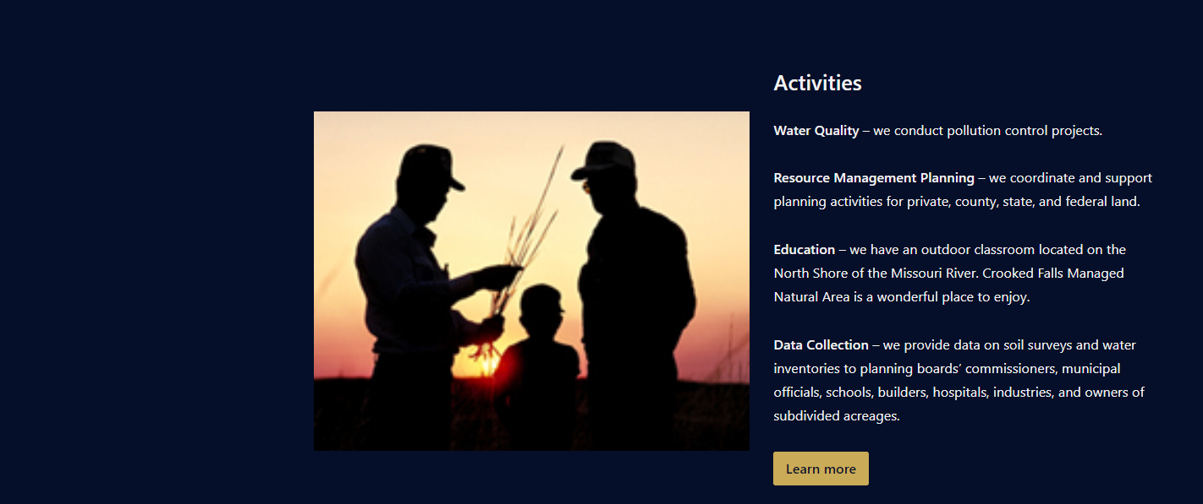
Each conservation district is comprised of local citizens elected as board members. They address a wide range of environmental concerns, providing education, resources, and programs to assist the communities they serve.
Education
Cascade Conservation District engages in educational activities with people of all ages to help them understand the value of conservation and how best to accomplish it.
Resources
From 310 Permits, information on available grants, and our many community partners, Cascade Conservation District provides the resources you need to strive.
Activities
Water Quality – we conduct pollution control projects.
Resource Management Planning – we coordinate and support planning activities for private, county, state, and federal land.
Education – we have an outdoor classroom located on the North Shore of the Missouri River. Crooked Falls Managed Natural Area is a wonderful place to enjoy.

About Us Page
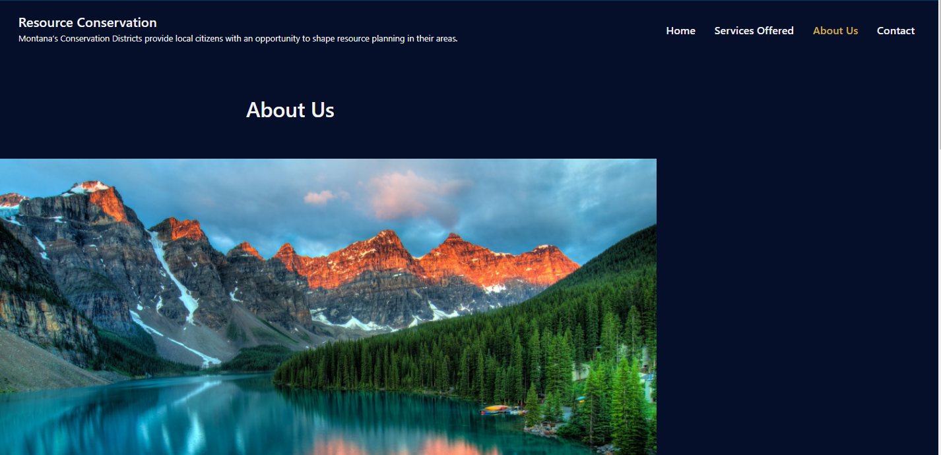
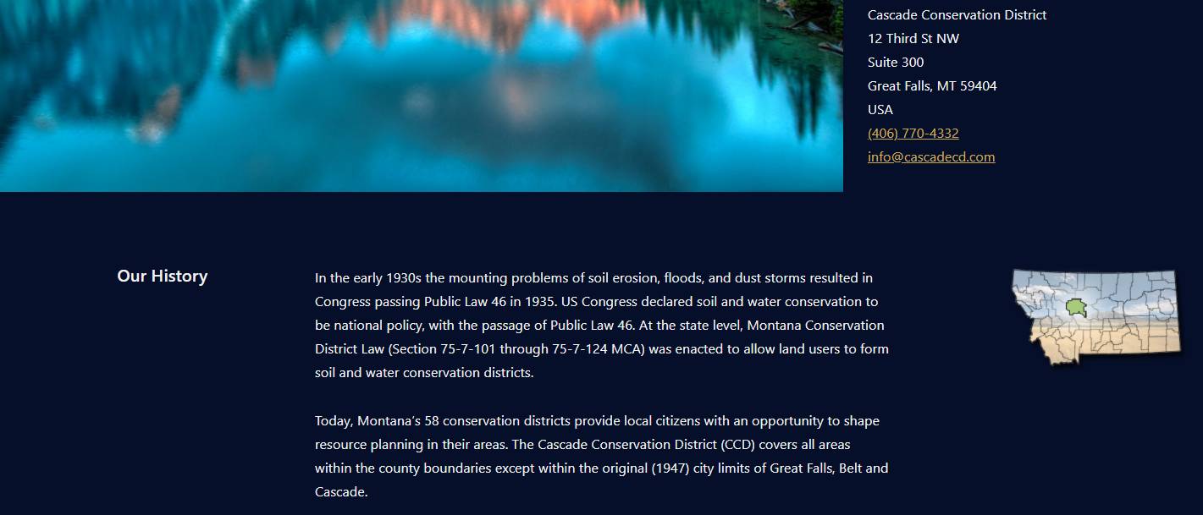
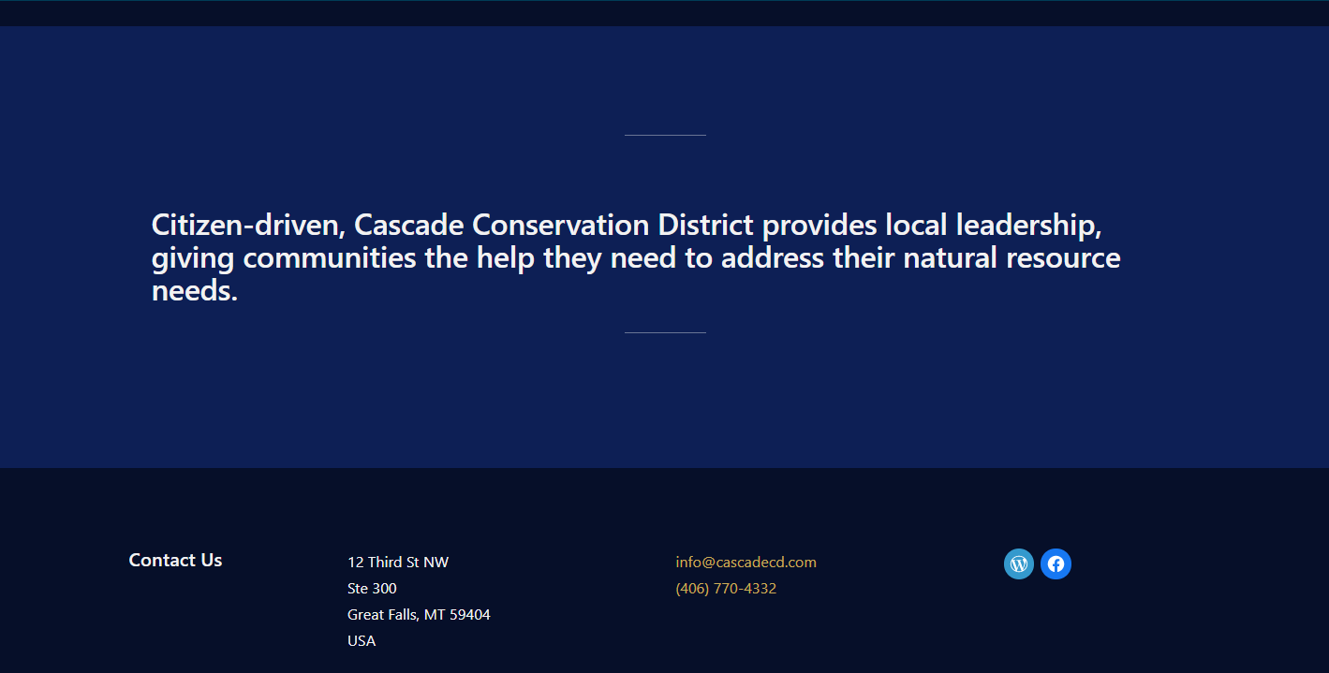
Cascade Conservation District
12 Third St NW
Suite 300
Great Falls, MT 59404
USA
(406) 770-4332
info@cascadecd.com
Our History
In the early 1930s the mounting problems of soil erosion, floods, and dust storms resulted in Congress passing Public Law 46 in 1935. US Congress declared soil and water conservation to be national policy, with the passage of Public Law 46. At the state level, Montana Conservation District Law (Section 75-7-101 through 75-7-124 MCA) was enacted to allow land users to form soil and water conservation districts.
Today, Montana’s 58 conservation districts provide local citizens with an opportunity to shape resource planning in their areas. The Cascade Conservation District (CCD) covers all areas within the county boundaries except within the original (1947) city limits of Great Falls, Belt and Cascade.
Citizen-driven, Cascade Conservation District provides local leadership, giving communities the help they need to address their natural resource needs.
Contact Us
Cascade Conservation District
12 Third St NW
Suite 300
Great Falls, MT 59404
USA
info@cascadecd.com
(406) 770-4332
Facebook hyperlink: https://www.facebook.com/CascadeConservationDistrict/

WP button hyperlink:
https://testdweeb.wordpress.com/

Contact US Page
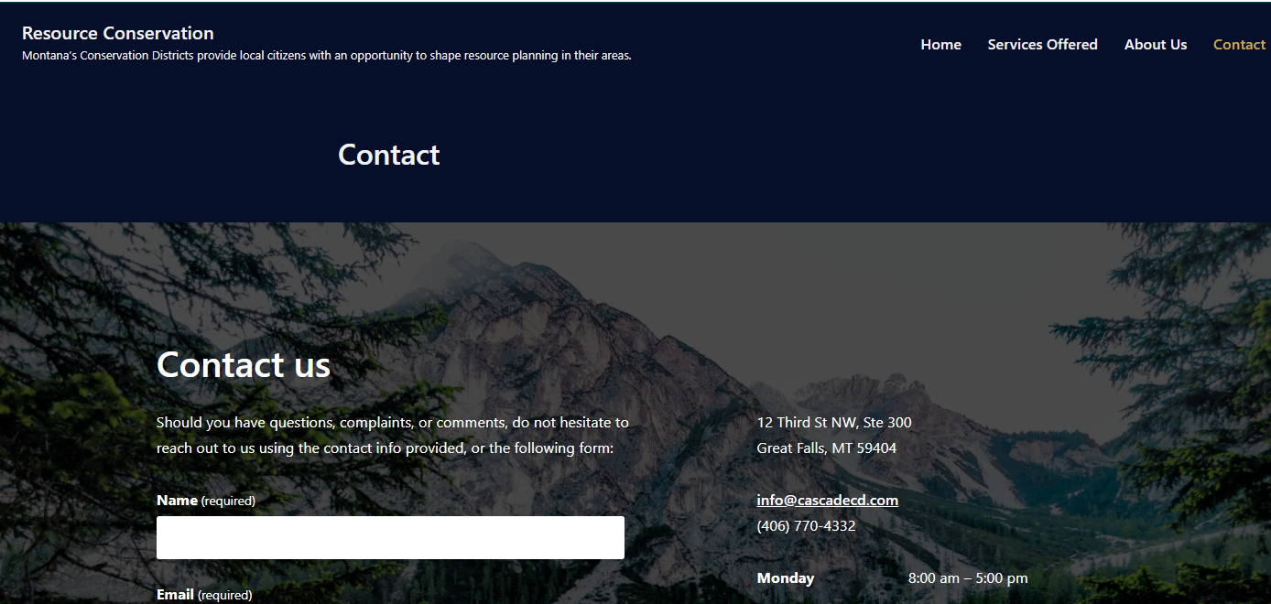
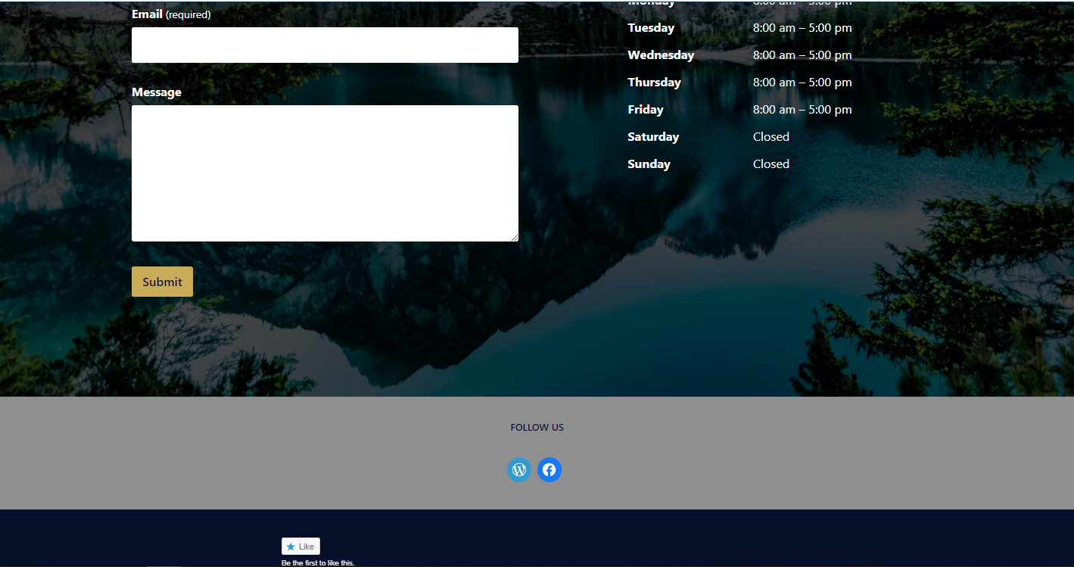
12 Third St NW, Ste 300
Great Falls, MT 59404

info@cascadecd.com
(406) 770-4332
Contact us
Should you have questions, complaints, or comments, do not hesitate to reach out to us using the contact info provided, or the following form:
Facebook hyperlink: https://www.facebook.com/CascadeConservationDistrict/

WP button hyperlink:
https://testdweeb.wordpress.com/

